Cron Jobs
Asynchronous jobs in HumHub are used to run potentially heavy or scheduled tasks such as sending out summary mails, notifications or search index optimization. The following section describes how to setup automatic job execution required to handle such jobs. Since those settings are highly dependent on your server environment we can't assure those setting will work for your. If you have trouble setting up the job scheduling described in this guide, please contact your provider to ask for support.

Overview#
There are two commands which needs to be scheduled:
- CronJob - cron/run
- Queue - queue/run

cron/run#
The cron command is used to run scheduled jobs which for example need to be executed hourly or daily. You can manually execute the cron command as follows:
php /path/to/humhub/protected/yii cron/run

queue/run#
The queue command is used to run asynchronous jobs which are potentially long running and therefore need to be executed in the background. The queue can either be scheduled as CronJob (see below) or with the help of another job-runner like for example Supervisor or Systemd. Please refer to the Asynchronous Tasks section for more details about queuing and job processing.
The queue command can be executed manually as follows:
php /path/to/humhub/protected/yii queue/run

CronJob configuration#
As mentioned before, the CronJob configuration highly depends on your server environment. The following section is meant to help you with the CronJob setup and includes a guide for some common environments.
If you are not using any other job-runner like Supervisor or Systemd for your queue, both commands can be scheduled as CronJob. Otherwise only the main cron/run command needs to be scheduled as CronJob.
CronTab example
* * * * * /usr/bin/php /path/to/humhub/protected/yii queue/run >/dev/null 2>&1
* * * * * /usr/bin/php /path/to/humhub/protected/yii cron/run >/dev/null 2>&1

important
If you're on a shared hosting environment, you may need to add the --isolate=0 option to the queue/run command e.g. /usr/bin/php /path/to/humhub/protected/yii queue/run --isolate=0.

caution
Make sure to use the right php cli executable for your jobs!

CloudLinux (CentOS) 6#
The following is a default setup for CloudLinux (CentOS) 6 and may not work for all users.
/usr/local/bin/php /home/USERNAME/public_html/WEB-DIRECTORY/protected/yii cron/run >/dev/null 2>&1
* * * * *
/usr/local/bin/php /home/USERNAME/public_html/WEB-DIRECTORY/protected/yii queue/run >/dev/null 2>&1
* * * * *

cPanel Hosted Server#
The following is a default setup for cPanel Hosted Server and may not work for all users.
/usr/local/bin/php /home/USERNAME/public_html/WEB-DIRECTORY/protected/yii cron/run >/dev/null 2>&1
* * * * *
/usr/local/bin/php /home/USERNAME/public_html/WEB-DIRECTORY/protected/yii queue/run >/dev/null 2>&1
* * * * *

IIS Windows Server#
Using Schtasks would be recommended over many other options for Windows 2012 and Windows 8 users.

Plesk#
Refer to this post
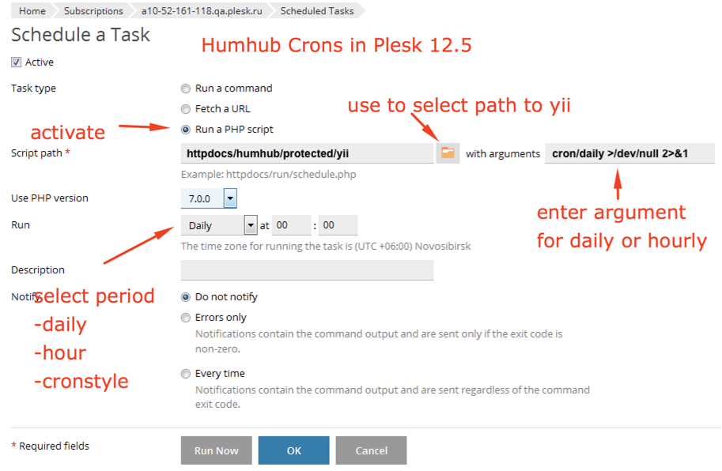

OVH#
Follow this link
Create the following files then follow the above link.
cronh.php
`<?php $humhubh = '/usr/local/php7.4/bin/php '.__DIR__.'/protected/yii cron/run '; exec($humhubh); ?>`
crond.php
<?php $humhubd = '/usr/local/php7.4/bin/php '.__DIR__.'/protected/yii queue/run '; exec($humhubd); ?>

Debian#
See also CronJob Setup.
Please read up on this article.

Ubuntu#
See also CronJob Setup.
Please read up on this how-to guide.

Status and Troubleshooting#
In case you encounter any issues with the job execution like unsent notifications or summary mails you can check the job status under Administration -> Information -> Background Jobs. Ideally the Last run time of the CronJob Status should be set and updated regularly. The value Waiting of Queue Status should decrease or be empty, while the Done value increases.
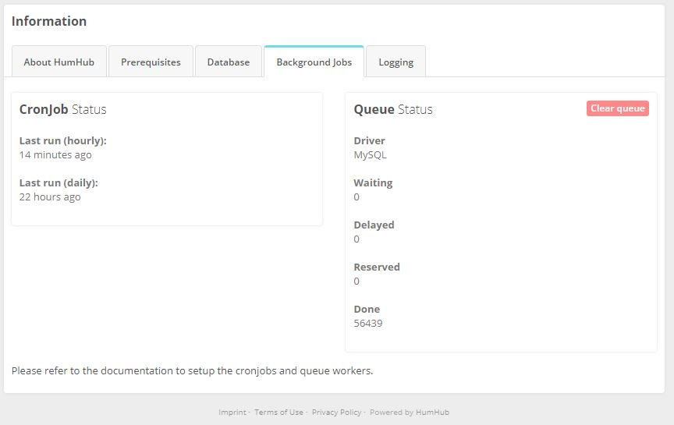
Troubleshooting can be done by checking the usual backend logs under Administration -> Information -> Background Jobs as well as using the following cron configuration to log the output of the command to a queue.log and cron.log file:
* * * * * /usr/bin/php /path/to/humhub/protected/yii queue/run >/path/to/queue.log 2>&1
* * * * * /usr/bin/php /path/to/humhub/protected/yii cron/run >/path/to/cron.log 2>&1
The log output may give you some hints about the problem and ideally should either be empty or filled with some stats if the job ran correctly. The modification time of the file furthermore informs you about the last time the cron job ran.
https://docs.humhub.org/docs/admin/cron-jobs/

